**AWS Cloud**

**Route53 & CloudFront**

**What is Amazon Route 53?**

Amazon Route 53 is a highly available and scalable Domain Name System (DNS) web service. You can use Route 53 to perform three main functions in any combination: domain registration, DNS routing, and health checking.

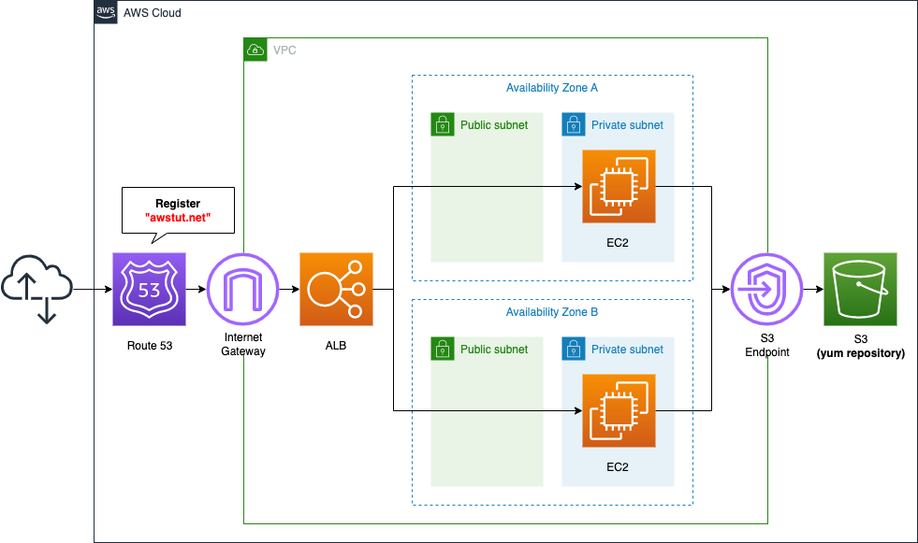

If you choose to use Route 53 for all three functions, be sure to follow the order below:

**1. Register domain names**

Your website needs a name, such as example.com. Route 53 lets you register a name for your website or web application, known as a *domain name*.

**2. Route internet traffic to the resources for your domain**

When a user opens a web browser and enters your domain name (example.com) or subdomain name (acme.example.com) in the address bar, Route 53 helps connect the browser with your website or web application.

**3. Check the health of your resources**

Route 53 sends automated requests over the internet to a resource, such as a web server, to verify that it's reachable, available, and functional. You also can choose to receive notifications when a resource becomes unavailable and choose to route internet traffic away from unhealthy resources.

**How internet traffic is routed to your website or web application**

All computers on the internet, from your smart phone or laptop connect to the servers that serve content for massive retail websites, communicate with one another by using numbers. These numbers, known as IP addresses, are in one of the following formats:

* Internet Protocol version 4 (IPv4) format, such as 192.0.2.44
* Internet Protocol version 6 (IPv6) format, such as 2001:0db8:85a3:0000:0000:abcd:0001:2345

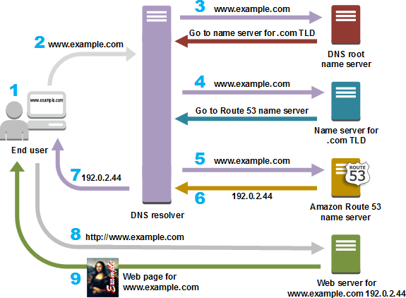When you open a browser and go to a website, you don't have to remember and enter a long string of characters like that. Instead, you can enter a domain name like example.com and still end up in the right place. A DNS service such as Amazon Route 53 helps to make that connection between domain names and IP addresses.

1. A user opens a web browser, enters www.example.com in the address bar, and presses
2. The request for www.example.com is routed to a DNS resolver, which is typically managed by the user's internet service provider (ISP), such as a cable internet provider, a DSL broadband provider, or a corporate network.
3. The DNS resolver for the ISP forwards the request for www.example.com to a DNS root name server.
4. The DNS resolver forwards the request for www.example.com again, this time to one of the TLD name servers for .com domains. The name server for .com domains responds to the request with the names of the four Route 53 name servers that are associated with the example.com domain.

The DNS resolver caches (stores) the four Route 53 name servers. The next time someone browses to example.com, the resolver skips steps 3 and 4 because it already has the name servers for example.com. The name servers are typically cached for two days.

1. The DNS resolver chooses a Route 53 name server and forwards the request for www.example.com to that name server.
2. The Route 53 name server looks in the example.com hosted zone for the www.example.com record, gets the associated value, such as the IP address for a web server, 192.0.2.44, and returns the IP address to the DNS resolver.
3. The DNS resolver finally has the IP address that the user needs. The resolver returns that value to the web browser.
4. The web browser sends a request for www.example.com to the IP address that it got from the DNS resolver. This is where your content is, for example, a web server running on an Amazon EC2 instance or an Amazon S3 bucket that's configured as a website endpoint.
5. The web server or other resource at 192.0.2.44 returns the web page for www.example.com to the web browser, and the web browser displays the page.

**How Amazon Route 53 checks the health of your resources**

**Amazon Route 53 health checks monitor the health of your resources such as web servers and email servers. You can optionally configure Amazon CloudWatch alarms for your health checks, so that you receive notification when a resource becomes unavailable.**

**Here's an overview of how health checking works if you want to be notified when a resource becomes unavailable**

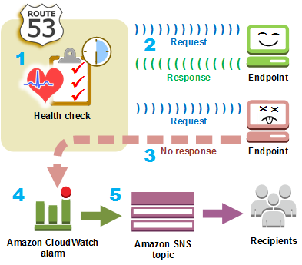

**Steps to Get Started**

1. **Log in to AWS Management Console**.
2. **Navigate to Route 53**.
3. **Create a Hosted Zone**:
   * Click on "Create Hosted Zone."
   * Enter the domain name.
   * Choose the type (Public or Private).

## DNS Record Types

### Common DNS Record Types Supported by Route 53

|  |  |
| --- | --- |
| **Record Type** | **Description** |
| A | Maps a domain name to an IPv4 address. |
| AAAA | Maps a domain name to an IPv6 address. |
| CNAME | Maps a domain name to another domain name. |
| MX | Defines mail servers for the domain. |
| TXT | Stores text-based information. |
| NS | Lists authoritative name servers. |
| SRV | Specifies location of services. |

### Create a CNAME Record

**Use Case**: Redirect blog.example.com to example.com.

#### Steps:

1. Go to your hosted zone.
2. Click on "Create Record."
3. Enter the following:
   * + - **Record Name**: blog
       - **Record Type**: CNAME
       - **Value**: example.com
       - **TTL**: 300 (default)
4. Save the record.

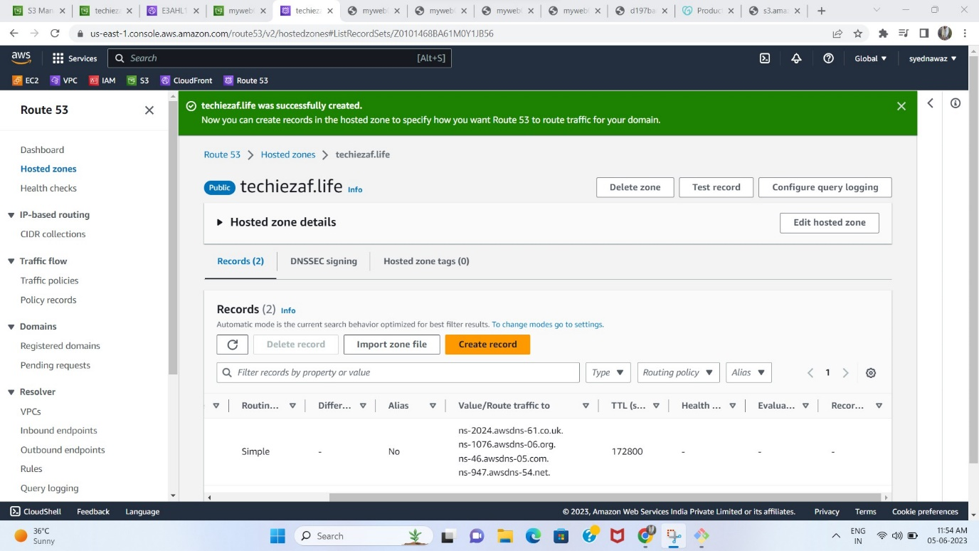

## Hosted Zones

* Route 53 automatically creates the Name Server (NS) and Start of Authority (SOA) records for the hosted zones.
* Route 53 creates a set of 4 unique name servers (a delegation set) within each hosted zone.
* Public hosted zone – route internet traffic to your resources
* Private hosted zone – route traffic within an Amazon VPC. You create a private hosted zone, and specify the VPCs that you want to associate with the hosted zone.  
  + To use private hosted zones, you must set the following VPC settings to true:  
    - enableDnsHostnames
    - enableDnsSupport
  + In a private hosted zone, you can associate Route 53 health checks only with failover, multivalue answer, weighted, latency, and, geolocation records.
  + You can use the following routing policies when you create records in a private hosted zone:

Simple

Failover

Multivalue answer

Weighted

Latency-based

Geolocation

## Records

* Create records in a hosted zone. Records define where you want to route traffic for each domain name or subdomain name. The name of each record in a hosted zone must end with the name of the hosted zone.
* Alias Records
  + Route 53 **alias records** provide a Route 53–specific extension to DNS functionality. Alias records let you route traffic to selected AWS resources. They also let you route traffic from one record in a hosted zone to another record.
  + You can create an alias record at the top node of a DNS namespace, also known as the zone apex.
* CNAME Record
  + You cannot create an alias record at the top node of a DNS namespace using a CNAME record.
* Alias records vs CNAME records

